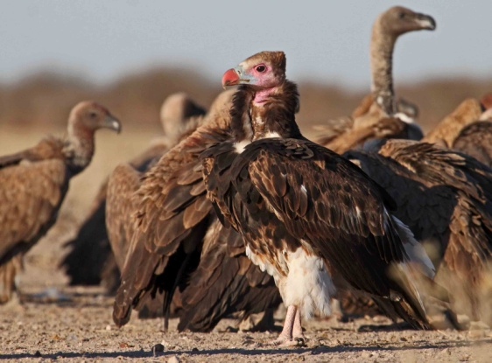
Botswana boasts a low human density coupled with vast, remote areas containing an abundance of wildlife. Denver Zoo works to understand the ecology and behavior of wildlife in Botswana and to gain insight into human-wildlife conflicts. The Central Kalahari region of Botswana experiences a high level of lion-human conflict due to the close proximity of cattle ranchers to the boundaries of the Central Kalahari Game Reserve. Denver Zoo studies lions trapped in farming areas and moved into the Central Kalahari Game Reserve, using satellites to track their movements and understand the effectiveness of translocations as a tool to reduce lion-farmer conflict. No group of animals has declined greater than scavengers over the past 20 years and vultures top the list of species now threatened with extinction, due to intentional and unintentional poisoning. Denver Zoo initiated an ecology and conservation project for vultures in Botswana, focused primarily Lappet-faced vultures (Torgos tracheliotos) and White-headed vultures (Trigonoceps occipitalis).
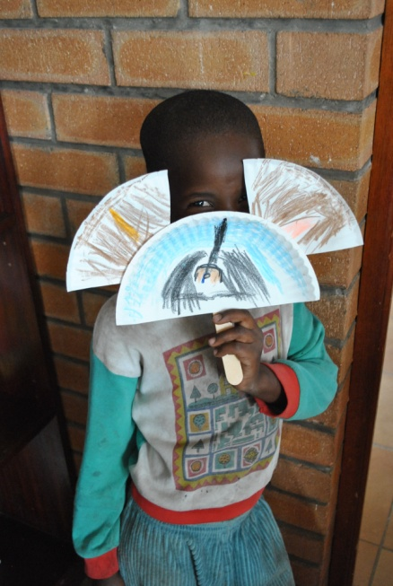
To complement current research in Botswana, Denver Zoo developed an education and outreach component to our conservation program, giving communities the knowledge and resources to participate in conservation and become empowered to make decisions that will help them live more sustainably with wildlife. Denver Zoo project leaders, Erin Stotz and Molly Maloy work to involve Botswana communities in positive, educational experiences in nature using books and literacy as a vehicle for conservation.
Denver Zoo currently works with two libraries in Botswana to incorporate wildlife conservation education into their after school programs. Using trunks modeled after another successful Denver Zoo sponsored project in Mongolia, Molly and Erin collaborated with local Botswana staff to develop a “safari trunk.” The trunks, kept in the library, are utilized by local communities as a tool for conservation education. Recently awarded a grant from the AZA Conservation Endowment Fund, Denver Zoo in partnership with SAVE Wildlife Fund promote wildlife conservation within libraries in Botswana by 1) fostering knowledge about and positive attitudes towards wildlife in primary school age children living near the Makgadikgadi Pans National Park, and 2) exposing children to future career opportunities in wildlife tourism and conservation sectors so they see a personal
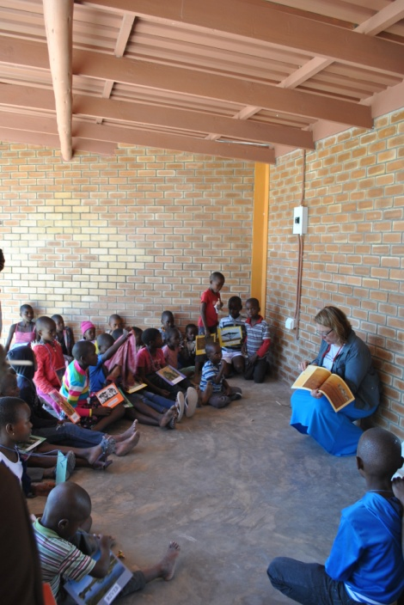
benefit to wildlife protection and the importance of wildlife to Botswana’s economy.
Denver Zoo also partners with Unite for Literacy, a Fort Collins-based social enterprise that unites people to support global literacy. Together, books have been designed based on Denver Zoo’s community-based wildlife conservation work in Botswana which focuses on developing positive attitudes and behaviors surrounding Botswana’s wildlife. The audio version of the books is narrated in Setswana, the language of Botswana. The books will educate families on Denver Zoo’s wildlife conservation work in Botswana and at the same time support Botswana’s goal of being a literate nation by 2016.

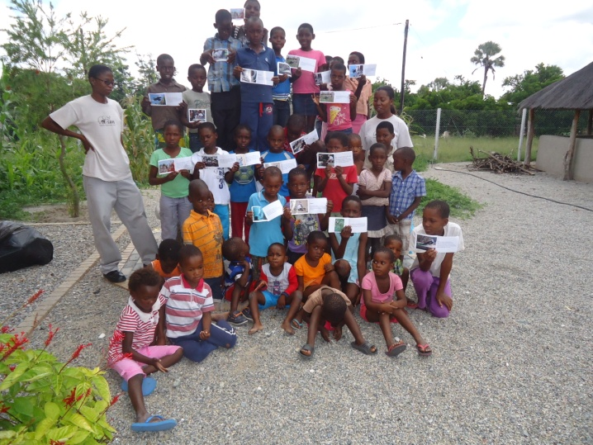
Last, Denver Zoo developed a partnership with Bontekanye Botumile (Bonte), a local Motswana woman who is an independent author and storyteller. Bonte’s aim is to reconnect local people to Botswana’s rich heritage; she believes that through the power of stories and storytelling, this can be accomplished. We are working with Bonte to create a story on vultures in order to promote vulture conservation throughout Botswana. Once published, we hope to act out her story through a series of plays performed by unemployed youth in the area in and around the town of Maun. This unique connection between culture and conservation creates a sense of community and direction for many young teenagers in the area.

